Bedford Borough Council – Local Plan 2040
Draft Plan Consultation Response Form

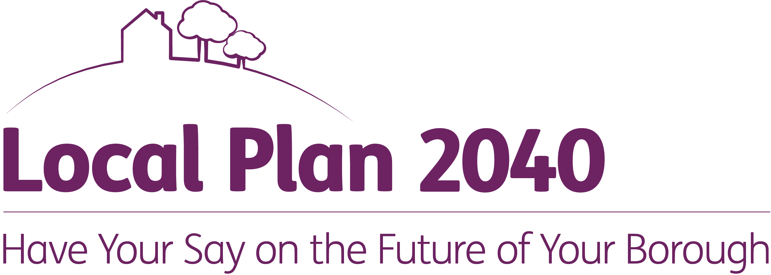
We would prefer to receive your comments via our online system www.bedford.gov.uk/localplan2040
In particular, if you are a planning consultant or agent please help us to speed up the production of local plans by using the online system. If you require assistance, please contact us on 01234 718070.

Please only use this form if you cannot respond online and to make your comments on the Local Plan 2040 Draft Plan and its supporting documents. You will need to have the document you want to comment on to hand so that you can enter the appropriate references. Copies of the document are available to view on the Council’s website www.bedford.gov.uk/LocalPlan2040 and in paper copy (by 45 minute appointment) at Bedford Central Library, Harpur Street, Bedford MK40 1PG (01234 718174). Subject to Covid restrictions being lifted on 19th July, paper copies will also be made available at all libraries in the borough, plus the key documents will be available at Rushden, St Neots, Biggleswade and Flitwick libraries during normal opening hours.

Please email this response form to us: planningforthefuture@bedford.gov.uk

Alternatively, responses can be sent by post. Please attach a stamp and send to:

Planning Policy Team
Bedford Borough Council
Borough Hall, Cauldwell Street
Bedford, MK42 9AP

PLEASE DO NOT SUBMIT COMMENTS IN MORE THAN ONE FORMAT OR SEND TO MORE THAN ONE EMAIL ADDRESS. If you have submitted comments electronically you do not need to print and post them. All responses (electronic and paper) must be received by 5pm on 3 September 2021.

Your contact information will be kept on the Planning Policy database so that we can keep you up to date about this and other planning policy documents. Personal data will be collected and processed in accordance with the Data Protection Act and the General Data Protection Regulations. Further information can be found on the council’s Data Protection webpage and in the Privacy Notices for planning policy.

All responses will be made public.

CONTACT DETAILS

Personal details

Title _____________________________________________________________

Name _____________________________________________________________

Job title (if applicable) _____________________________________________________________

Organisation (if applicable) _____________________________________________________________

Address _____________________________________________________________

_____________________________________________________________

Postcode _____________________________________________________________

Telephone Number _____________________________________________________________

Email _____________________________________________________________

AGENT DETAILS (if applicable)
If you are a planning consultant or agent, you can do this on-line. You will be able to save a draft to complete later, save the final version for your records, save paper and speed up plan making. If you require assistance, please call 01234 718070
Title ______________________________________________________________

Name ______________________________________________________________

Job title (if applicable) _____________________________________________________________

Organisation (if applicable) _____________________________________________________________

Address _____________________________________________________________

_____________________________________________________________

Postcode _____________________________________________________________

Telephone Number _____________________________________________________________

Email _____________________________________________________________

If you are using an agent, who would you prefer any correspondence to go to?
(Please mark X one box only)
Contact agent Contact client Contact both

Your interest (Please mark X one box only)
Land owner Resident Consultant Agent Other

Please specify 'Other' (please write in)

Please use a separate form (this page) for each consultation document paragraph, policy or evidence base document you are commenting on.

Which paragraph number, policy number or evidence base document are you commenting on?

Please add your comments in the box below, and continue on an additional sheet if necessary.

