Eaton Bank
A new large development site submitted to Bedford Borough Council’s Local Plan 2040

Staploe Parish Council would like to make you aware of a large new development site which has been submitted to Bedford Borough Council by Thakeham Developers for the land between Duloe and the A1. The site is referred to as Eaton Bank. It proposes between 2500-3000 homes over 154ha. Thakeham envisage a sustainable, zero carbon development. The site was submitted on 2nd September and the Local Plan consultation closed on 3rd September.

https://staploe-pc.gov.uk/eaton-bank-vision-document/

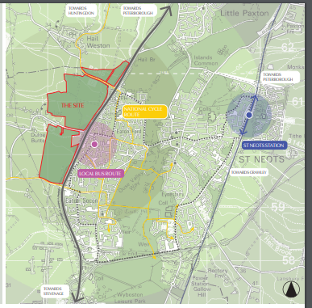
(Source: p6 of the Eaton Bank Vision Document – produced by Thakenham)
The Parish Council have an extension to respond to the Local Plan 2040 by 17th September. We object to the development and have drafted a letter which you may wish to send to us and copy the planners. We feel it is important for people to send it to us before 9pm on Wednesday so that we can include your comments in our representations to the Local Plan.
If you do want to send this objection please add your address and date in the top right corner, sign the bottom of the letter and add your printed name(s) below. You may also wish to add your own comments.

Please return the letter by putting it in Ged Meola’s postbox, 49, Woodhouse Lane, Duloe, or Lucy Crawford’s at 33, Staploe or scan and e-mail it to Lucy at clerk@staploe-pc.gov.uk. If you have any questions please contact Lucy on 01480 471 526

