Staploe Parish Council
33, Staploe,
St Neots
Bedfordshire
PE19 5JA

Dear Mrs Crawford,
I would like to register my objection to the site known as Eaton Bank in Duloe shown below and ask you to pass it on to the Planning for the Future Team at Bedford Borough Council.
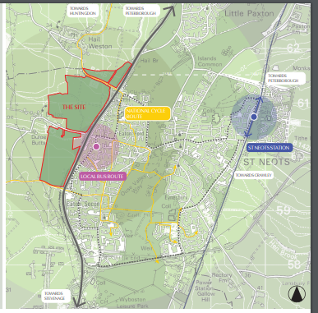
Figure 1 Eaton Bank development. Source:Eaton Bank Vision Document p6, Thakeham.
My objection is based on the following:
- It was submitted one day before the consultation closed and there was no opportunity for residents to comment on it.
- This is a rural location currently classed as open countryside. A recent neighbourhood plan survey clearly showed that residents (including ourselves) do not support extensive development in our parish. We value our parish for its quiet, rural environment, its wildlife and its countryside views.
- This is a greenfield site on grade 2 agricultural land. We do not support the use of high quality agricultural land for housing development.
- The local roads in Duloe are totally unsuitable for large scale development and widening the roads would damage the rural character of the hamlet. The approaches to St Neots on the Bushmead Road are through a residential area past a primary school and not suited to large increases in traffic.
- The location is sufficiently far from a rail station that it would necessitate a car journey to access it. The bus service from Eaton Socon would necessitate a 20 minute walk to the bus stop at Meadowsweet followed by a 20 minute journey to the main rail station. People are far more likely to use their cars for a 10 minute drive to the station.
- The A1 has been the boundary between the urban area of Eaton Socon and the completely rural area to the west for 70 years. St Neots is already expanding with significant, planned urban extensions to the east; to add 3000 homes directly to the west would put unsustainable pressure on the services in St Neots and change the character of this market town. It would also cause coalescence of St. Neots / Eaton Socon and Duloe which is contrary to planning policy.
- This site is directly adjacent to the A1. There has been talk for many years of upgrading the A1 in this area. A development here makes any improvements / widening in situ impossible.
- The delivery of this site is likely to be slow as it will require careful planning with St Neots Town Council and Huntingdonshire District Council.

Best wishes,

